**Title: Install fedora workstation using virtual environment to demonstrate working of open source-based platform**

**Objective:**

The objective of this experiment is to install Fedora Workstation, an open-source-based platform, using a virtual environment and demonstrate its functionalities and features.

**Requirements:**

Virtualization tool

Fedora iso

**Procedure/Experiment Steps:**

1. Set Up Virtual Environment: Install virtualization software (e.g., Oracle VM VirtualBox) on your computer, ensuring that it meets the system requirements.
2. Download Fedora Workstation: Obtain the Fedora Workstation ISO image from the official Fedora website (https://getfedora.org).
3. Create a Virtual Machine: Open the virtualization software and create a new virtual machine. Configure the virtual machine settings, including the name, memory size, hard disk, and network settings.
4. Install Fedora Workstation: Attach the Fedora Workstation ISO image to the virtual machine's optical drive. Start the virtual machine and follow the on-screen instructions to install Fedora Workstation.

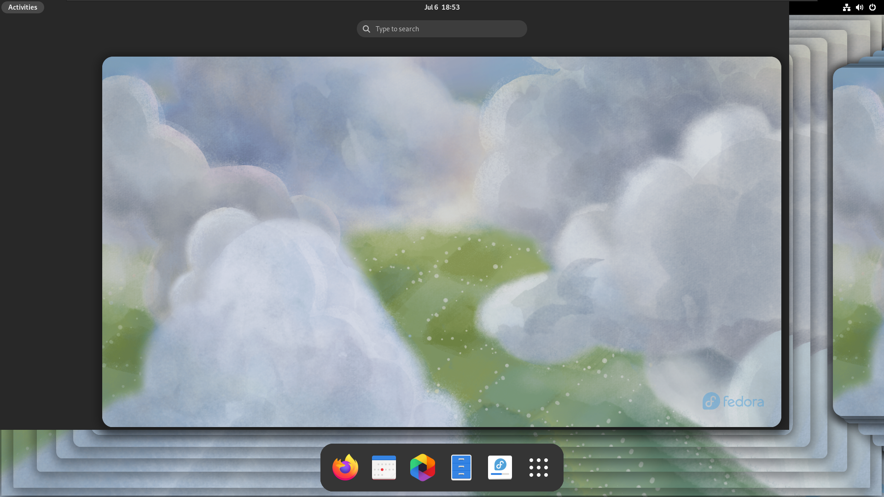

1. Configure Fedora Workstation: Set up Fedora Workstation by providing necessary information during the installation process, such as the language, time zone, user account, and network settings.
2. Explore Fedora Workstation: Once the installation is complete, launch Fedora Workstation within the virtual machine and familiarize yourself with its interface, applications, and functionalities.

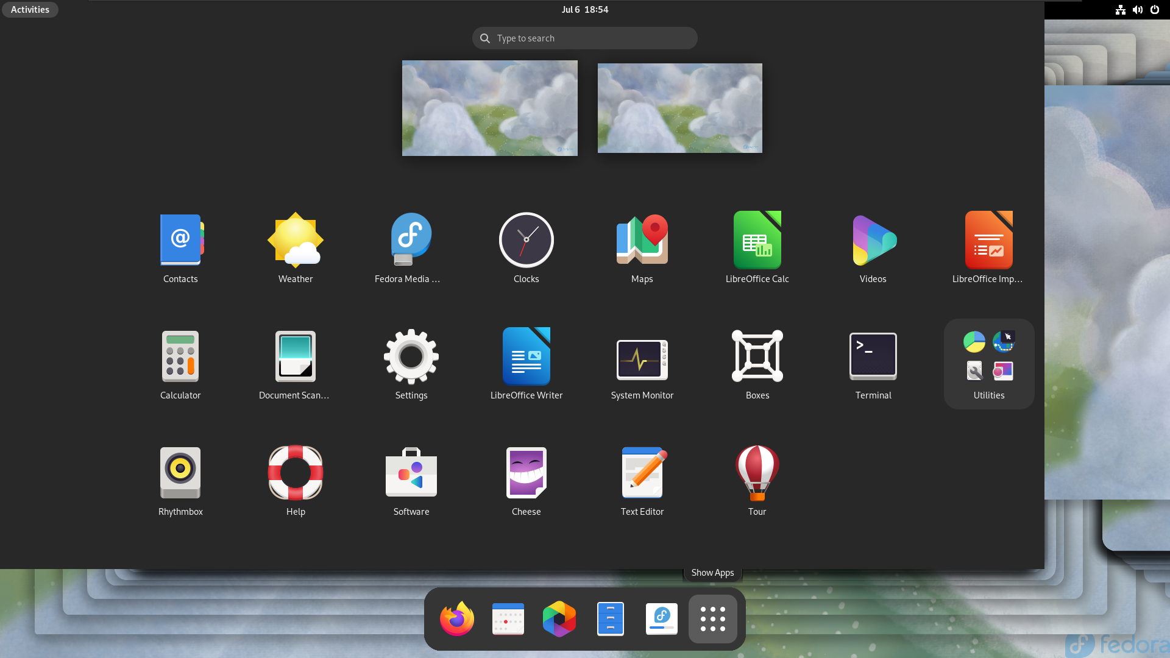

1. Document Observations: Record your observations and experiences while working with Fedora Workstation, highlighting notable features, performance, and user-friendliness.

**Result:**

By setting up a virtual environment and installing Fedora Workstation, we successfully demonstrated the functionalities and features of this open-source-based platform. After configuring the necessary settings during installation, we explored the GNOME desktop environment, utilized software management tools, and performed tasks such as web browsing, document editing, and file management. Throughout the demonstration, we documented our observations, noting key features, performance, and overall user experience.

**Conclusion:**

Fedora Workstation, as an open-source-based platform, provides a robust and user-friendly environment for productivity and various computing tasks. By installing Fedora Workstation in a virtual environment, we showcased its key features, including the GNOME desktop environment, software management, and customization options. Fedora Workstation proves to be a viable open-source choice for individuals and organizations seeking a reliable and feature-rich operating system.

**Future Scope:**

1. Advanced customization: Explore advanced customization options within Fedora Workstation, such as desktop theming, extensions, and application integration.
2. Software development environment: Utilize Fedora Workstation for software development purposes, leveraging its tools, libraries, and package management system.
3. Security features: Investigate the security features and tools available in Fedora Workstation, such as SELinux (Security-Enhanced Linux) and firewall configuration.
4. Integration with enterprise solutions: Explore the integration of Fedora Workstation with enterprise solutions and services, such as cloud platforms or centralized user management systems.
5. Stay updated with Fedora: Regularly update Fedora Workstation to benefit from the latest software updates, security patches, and new features, ensuring a stable and secure computing environment.